ASSIGNMENT 9.1
Name: K.uma maheshwari
2303a52430
Batch:44
Problem 1:
Consider the following Python function:
def find_max(numbers):
return max(numbers)
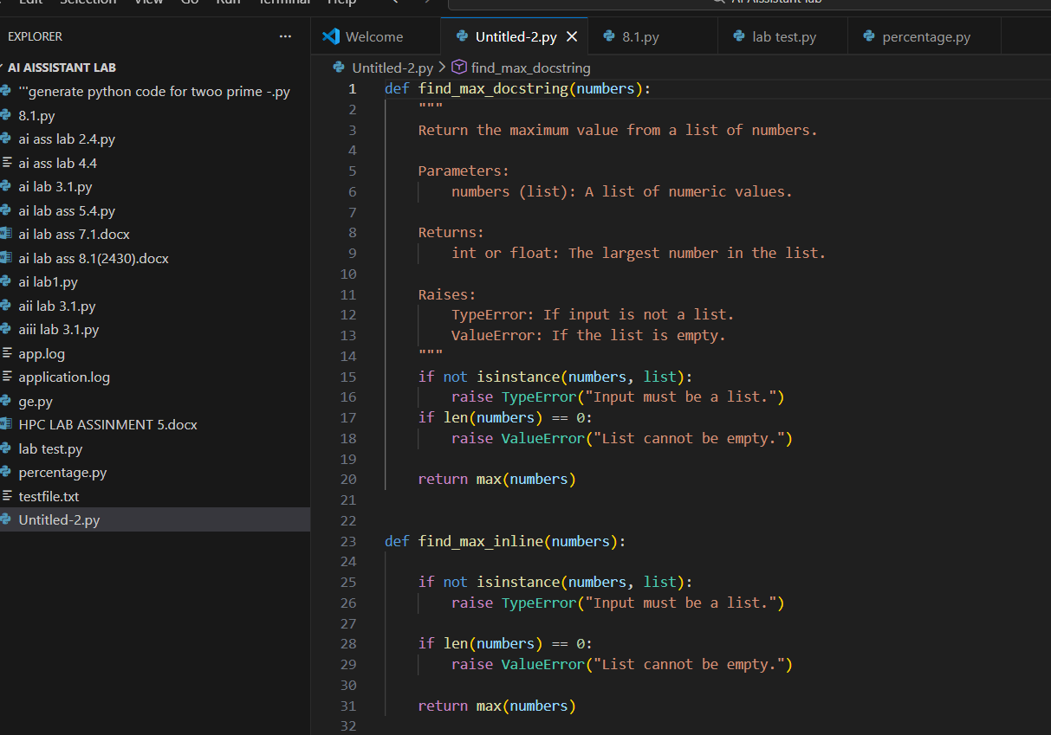
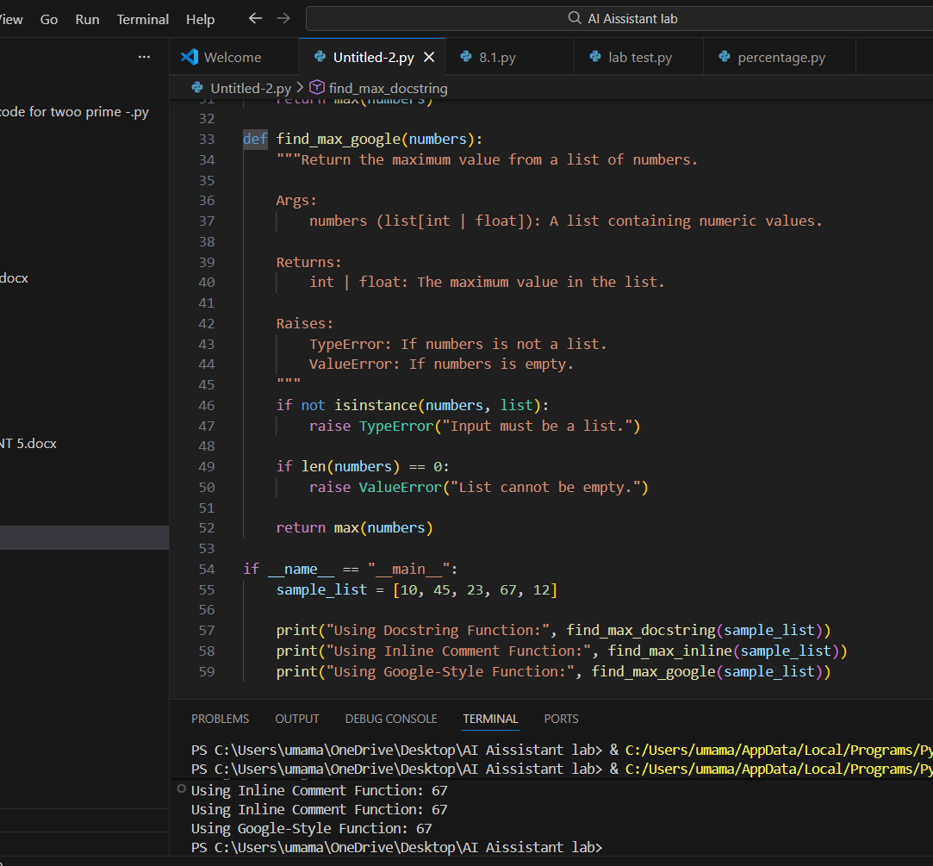
Problem 2:
Consider the following Python function:
def login(user, password, credentials):
return credentials.get(user) == password
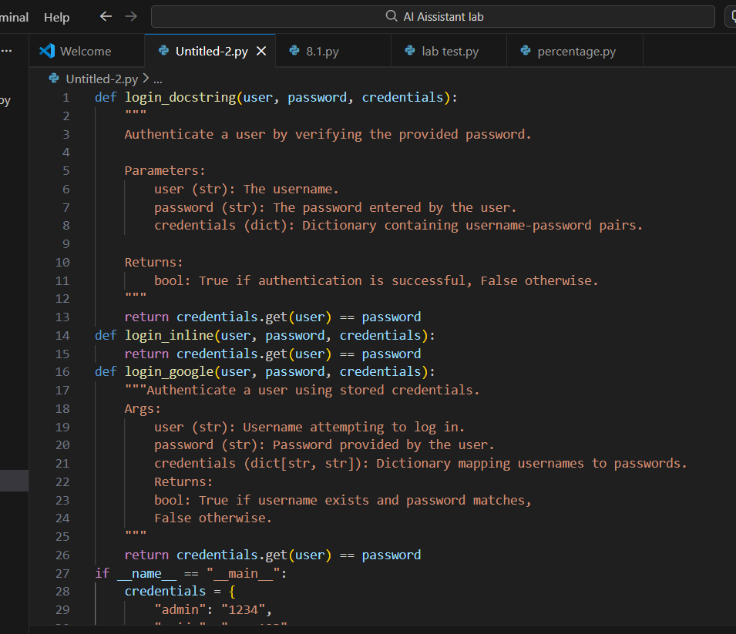
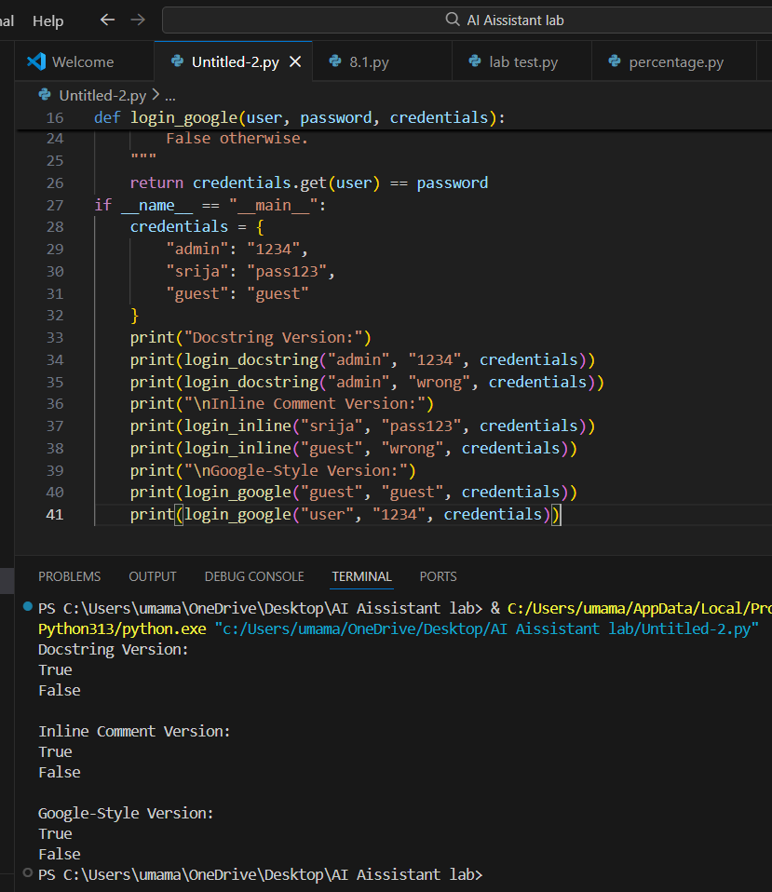
Problem 3: Calculator (Automatic Documentation Generation)
Task: Design a Python module named calculator.py and
demonstrate automatic documentation generation.
Instructions:

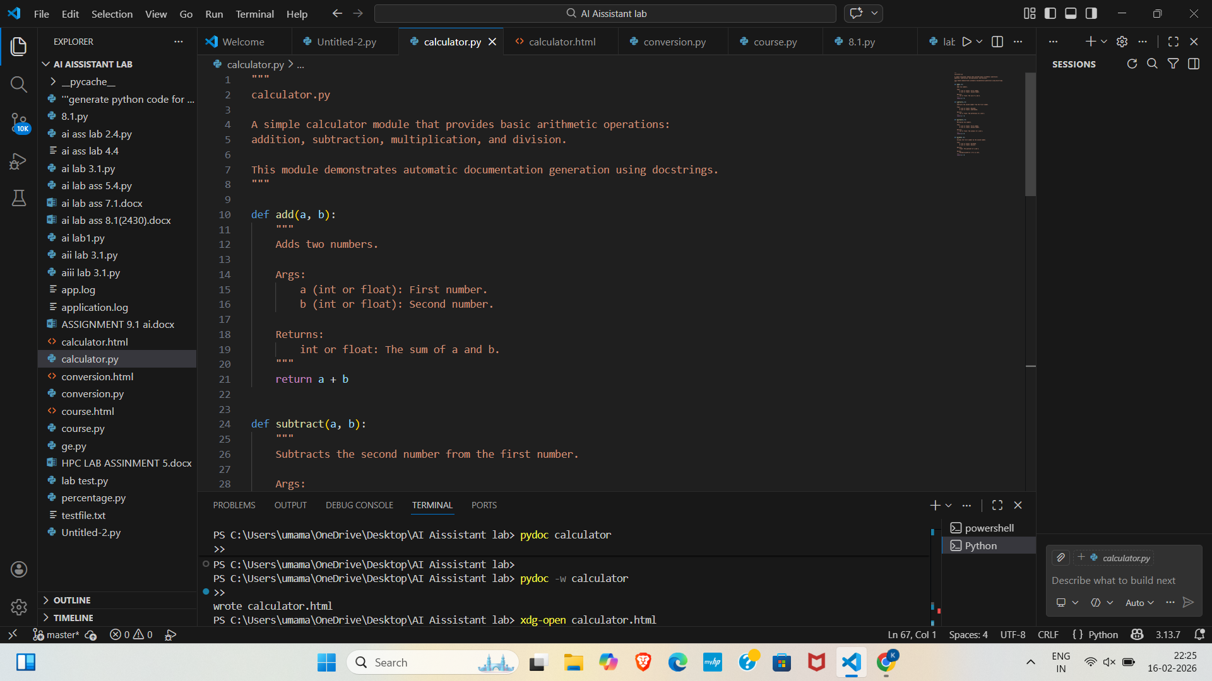
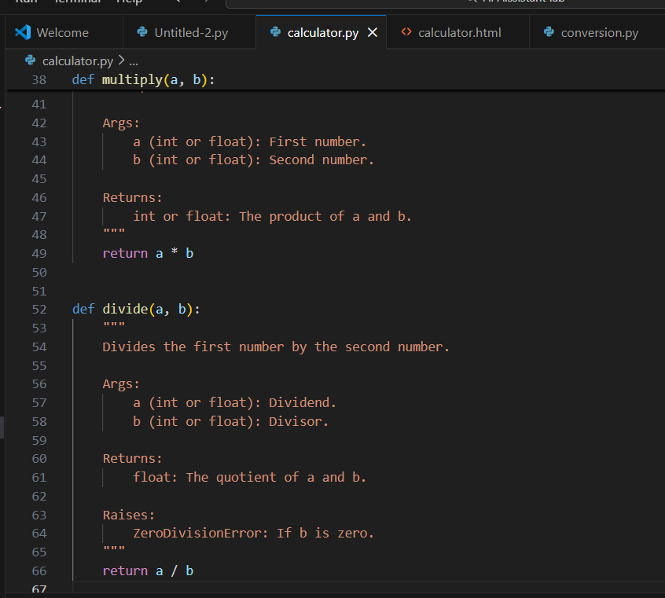
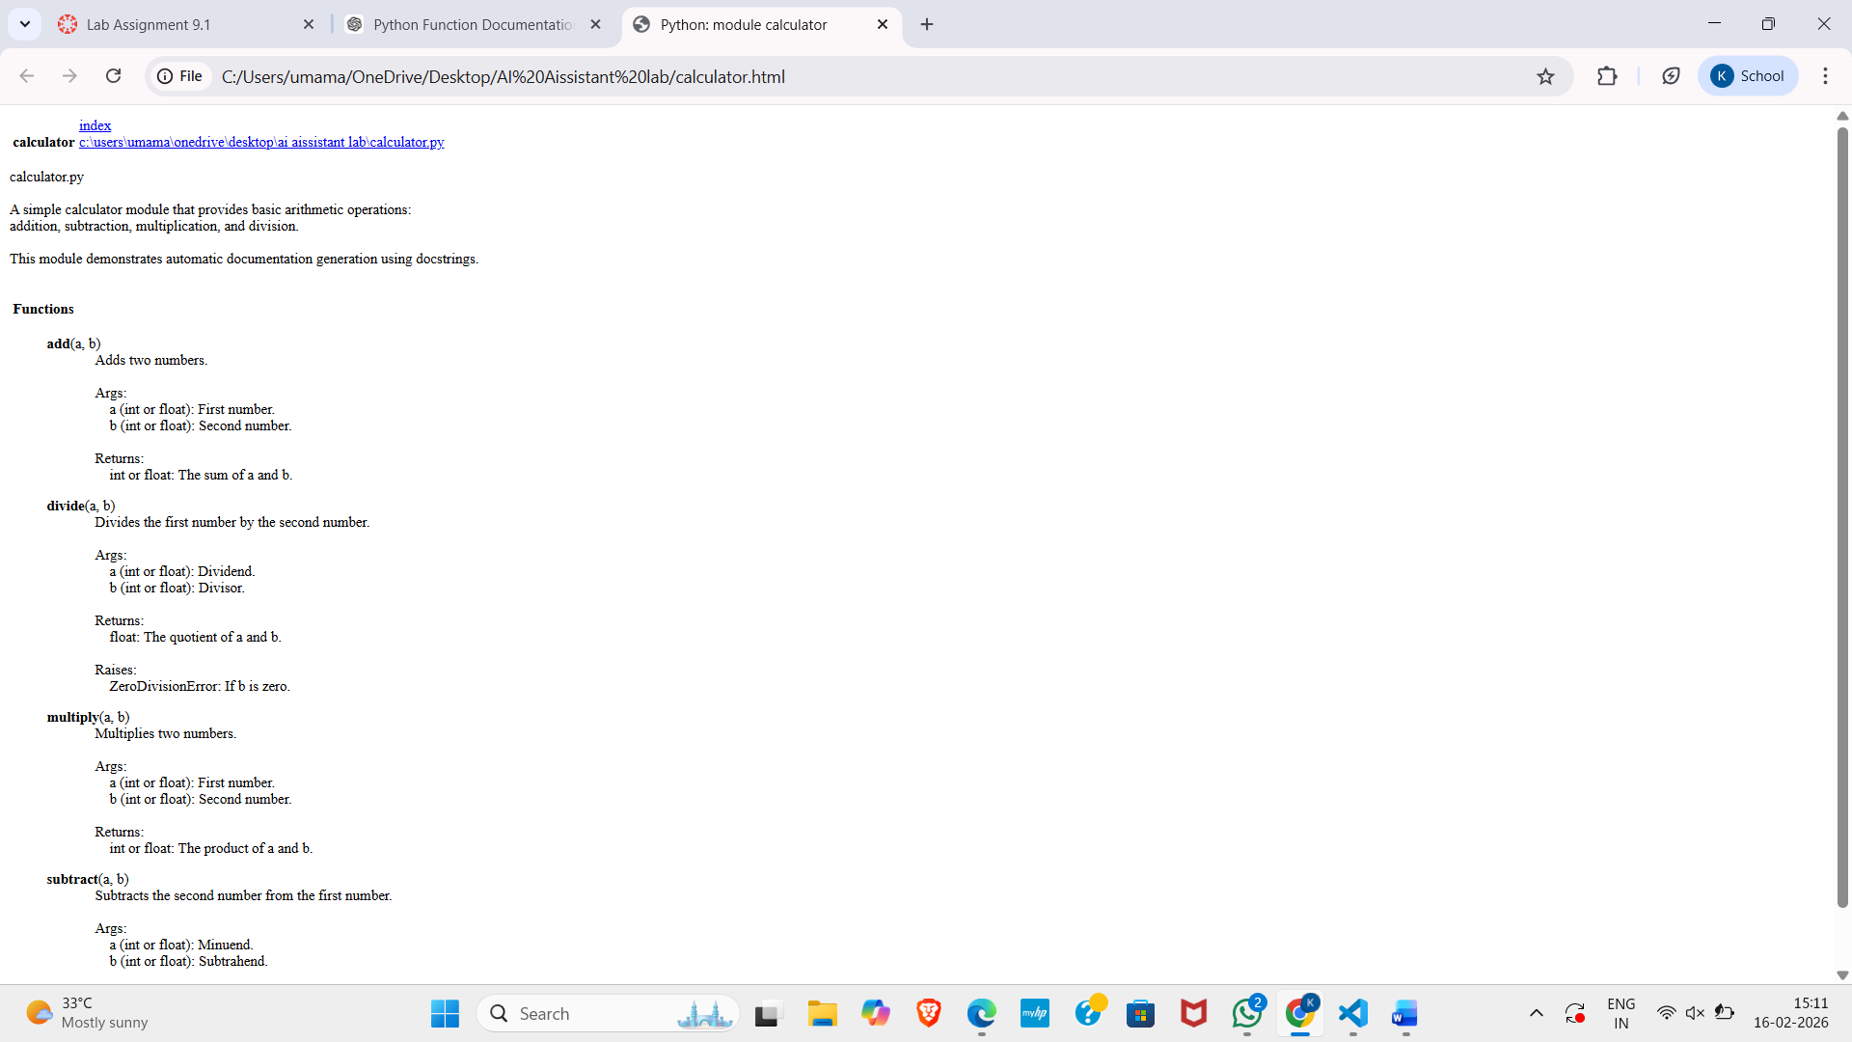
4:Conversion Utilities Module
Task:
1. Write a module named conversion.py with functions:
o decimal_to_binary(n)
o binary_to_decimal(b)
o decimal_to_hexadecimal(n)
2. Use Copilot for auto-generating docstrings.
3. Generate documentation in the terminal.
4. Export the documentation in HTML format and open it in a
Browser
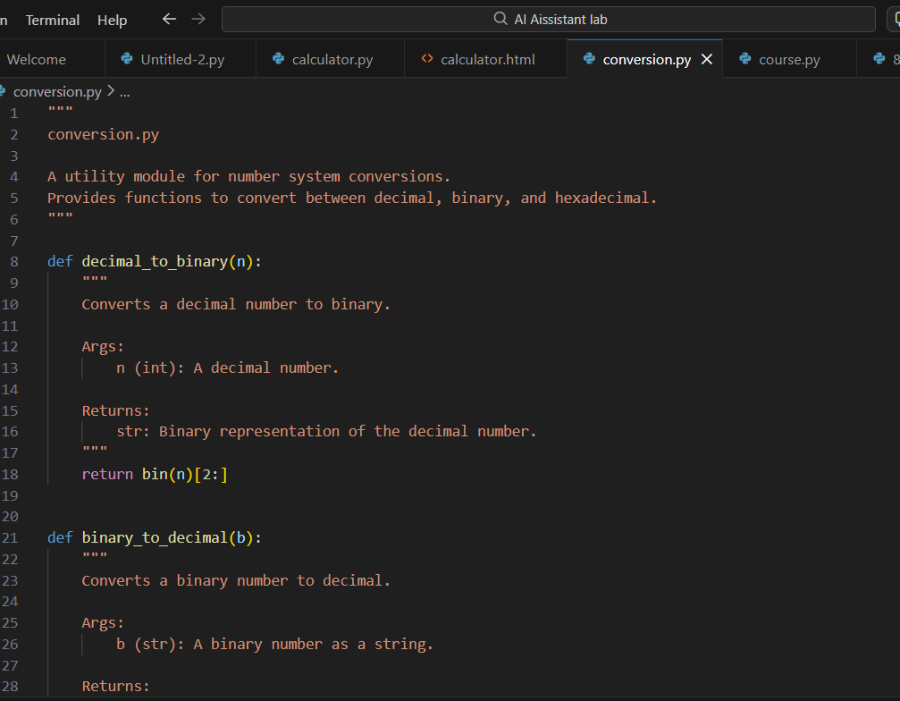
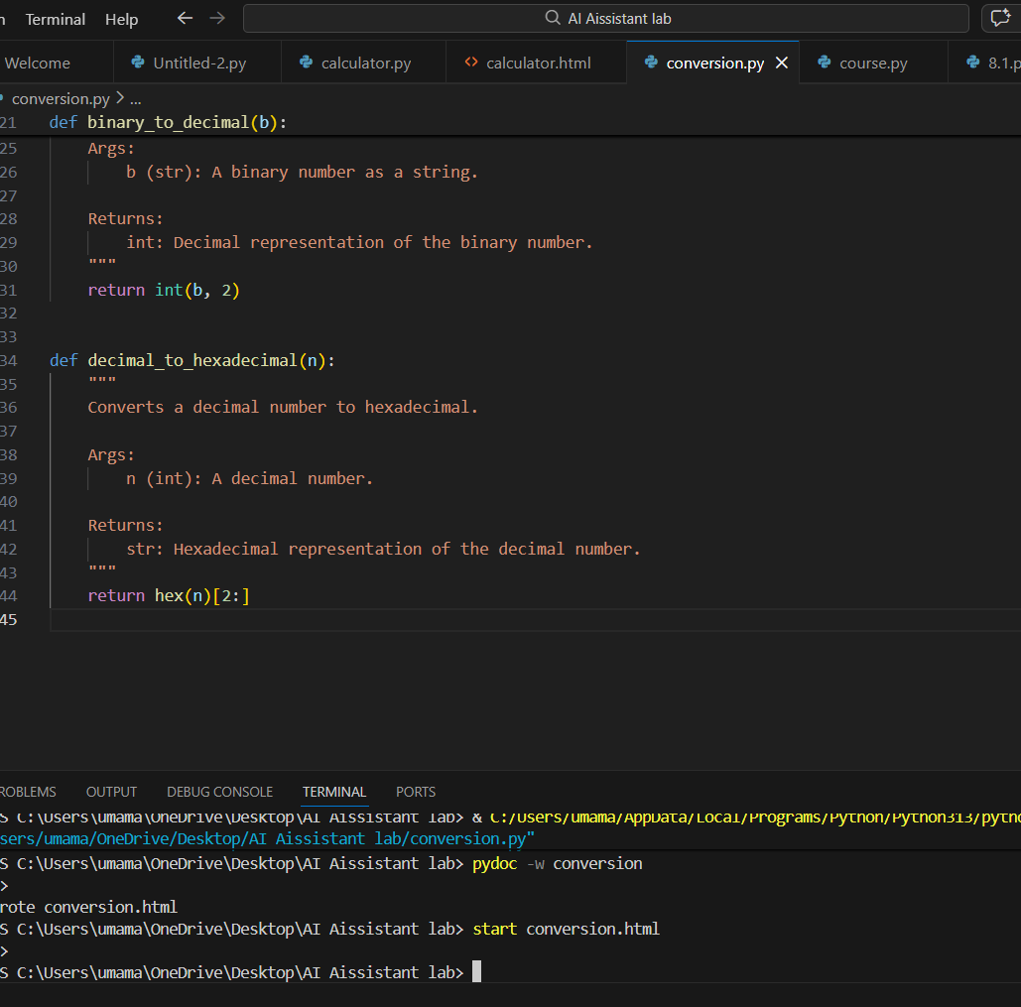
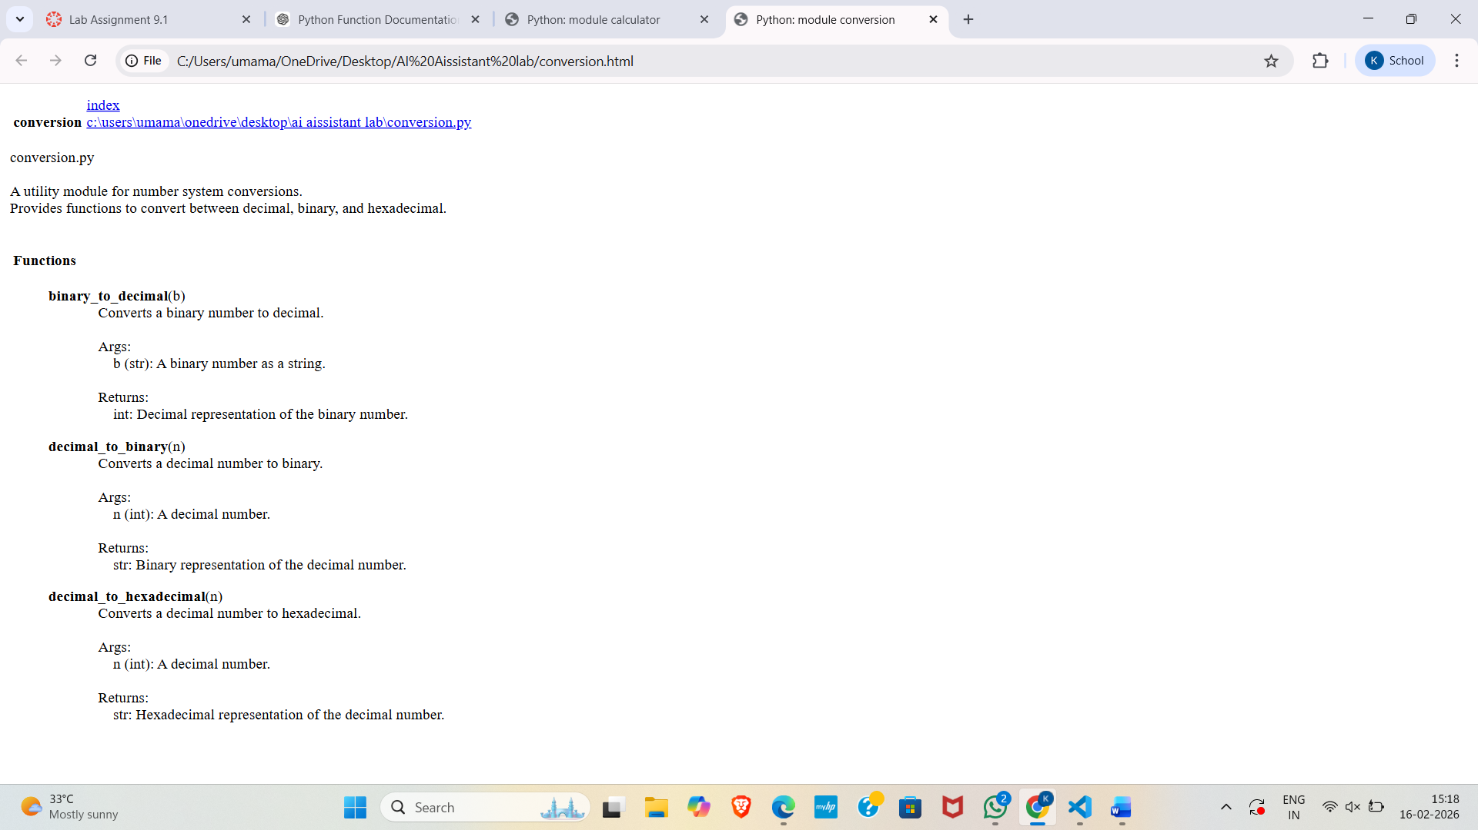

5: Course Management Module
